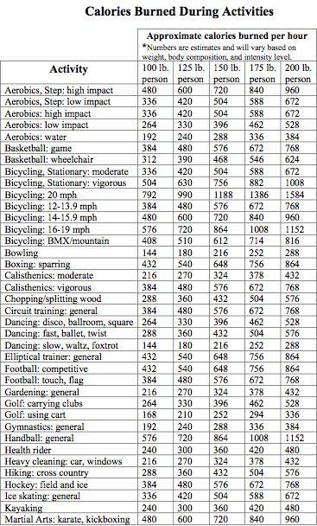
Name:________________________________ Class#:________________
Date | activity | # of steps | # of laps  (for TT) | # of miles  (4 laps=1 mile)  Or use chart | Cals  Burned  (divide by 2)
 | Turkey Trot
 |  |  | ----------
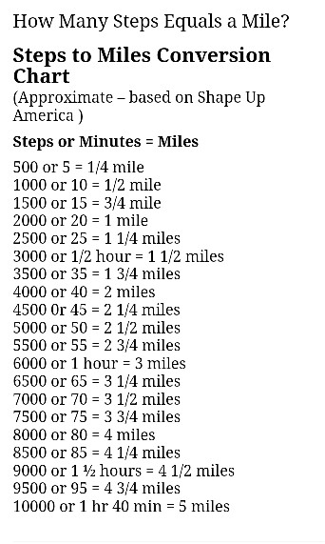
Which day/activity was more intense? (more steps, miles, calories etc.) __________________

Which day/activity is more beneficial?____________________________
Why? In other words, what was different about your performance in the other activity as compared to the turkey trot?_____________________________________________________
____________________________________________________________________________________________________________________________________________________________________________________________________________________________________

What connections can you make between intensity of the activity and the benefits you gain?
________________________________________________________________________________________________________________________________________________________________________________________________________________________________________________________________________________________________________________________________________________________________________________________________________________________________________________________________________

